**Assignment-1 [Data Types]**

[Submitted by **Malika Hafiza Pasha**]

**Please implement by using Python.**

1. Construct 2 lists containing all the available data types (integer, float, string, complex and Boolean) and do the following.
   1. Create another list by concatenating above 2 lists
   2. Find the frequency of each element in the concatenated list.
   3. Print the list in reverse order.

**Answer:** [Python file is attached with the assignment file]

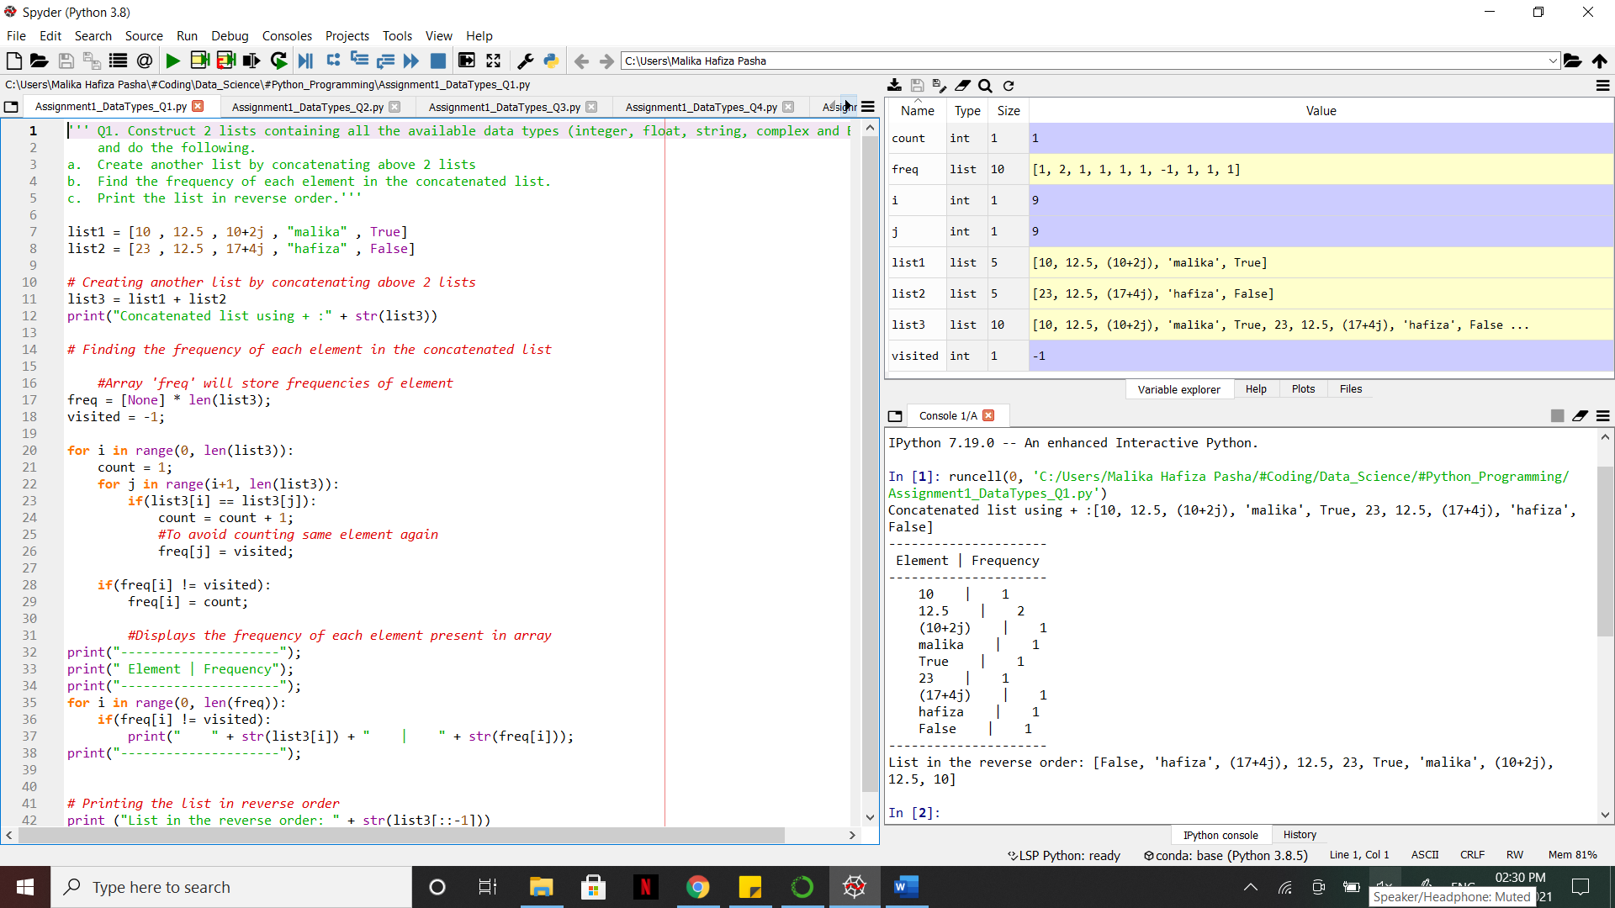

1. Create 2 Sets containing integers (numbers from 1 to 10 in one set and 5 to 15 in other set)
   1. Find the common elements in above 2 Sets.
   2. Find the elements that are not common.
   3. Remove element 7 from both the Sets.

**Answer:** [Python file is attached with the assignment file]

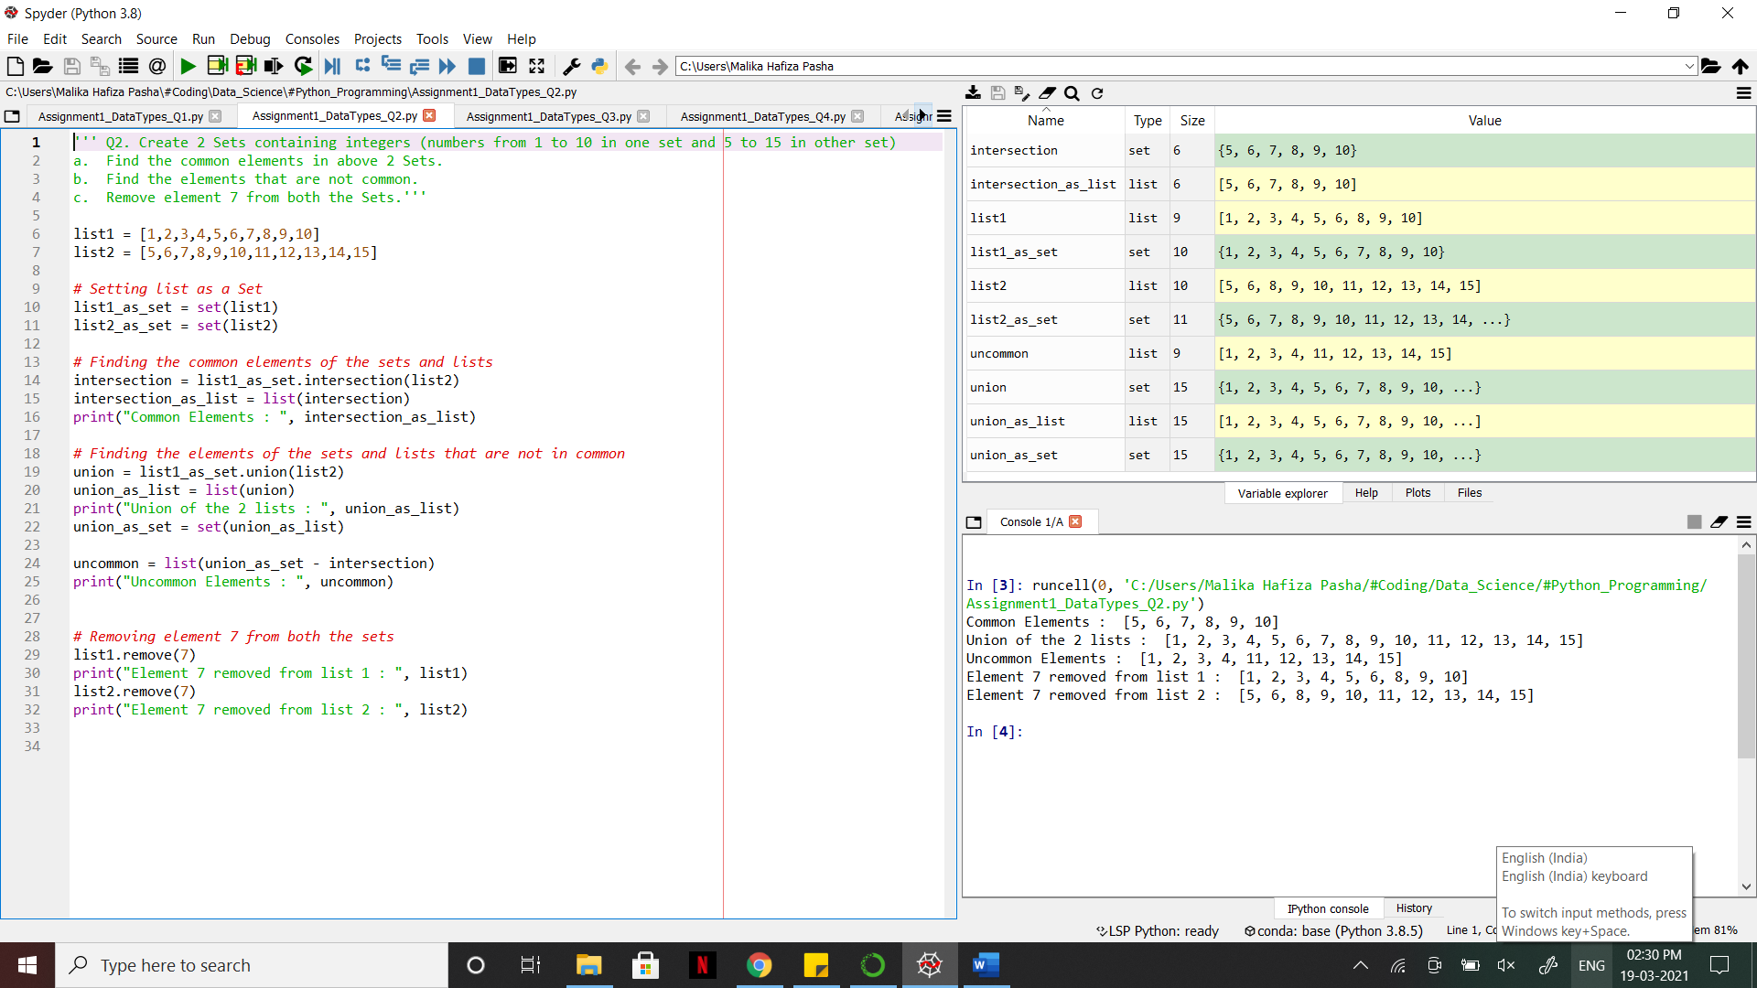

1. Create a data dictionary of 5 states having state name as key and number of covid-19 cases as values.
   1. Print only state names from the dictionary.
   2. Update another country and it’s covid-19 cases in the dictionary.

**Answer:** [Python file is attached with the assignment file]

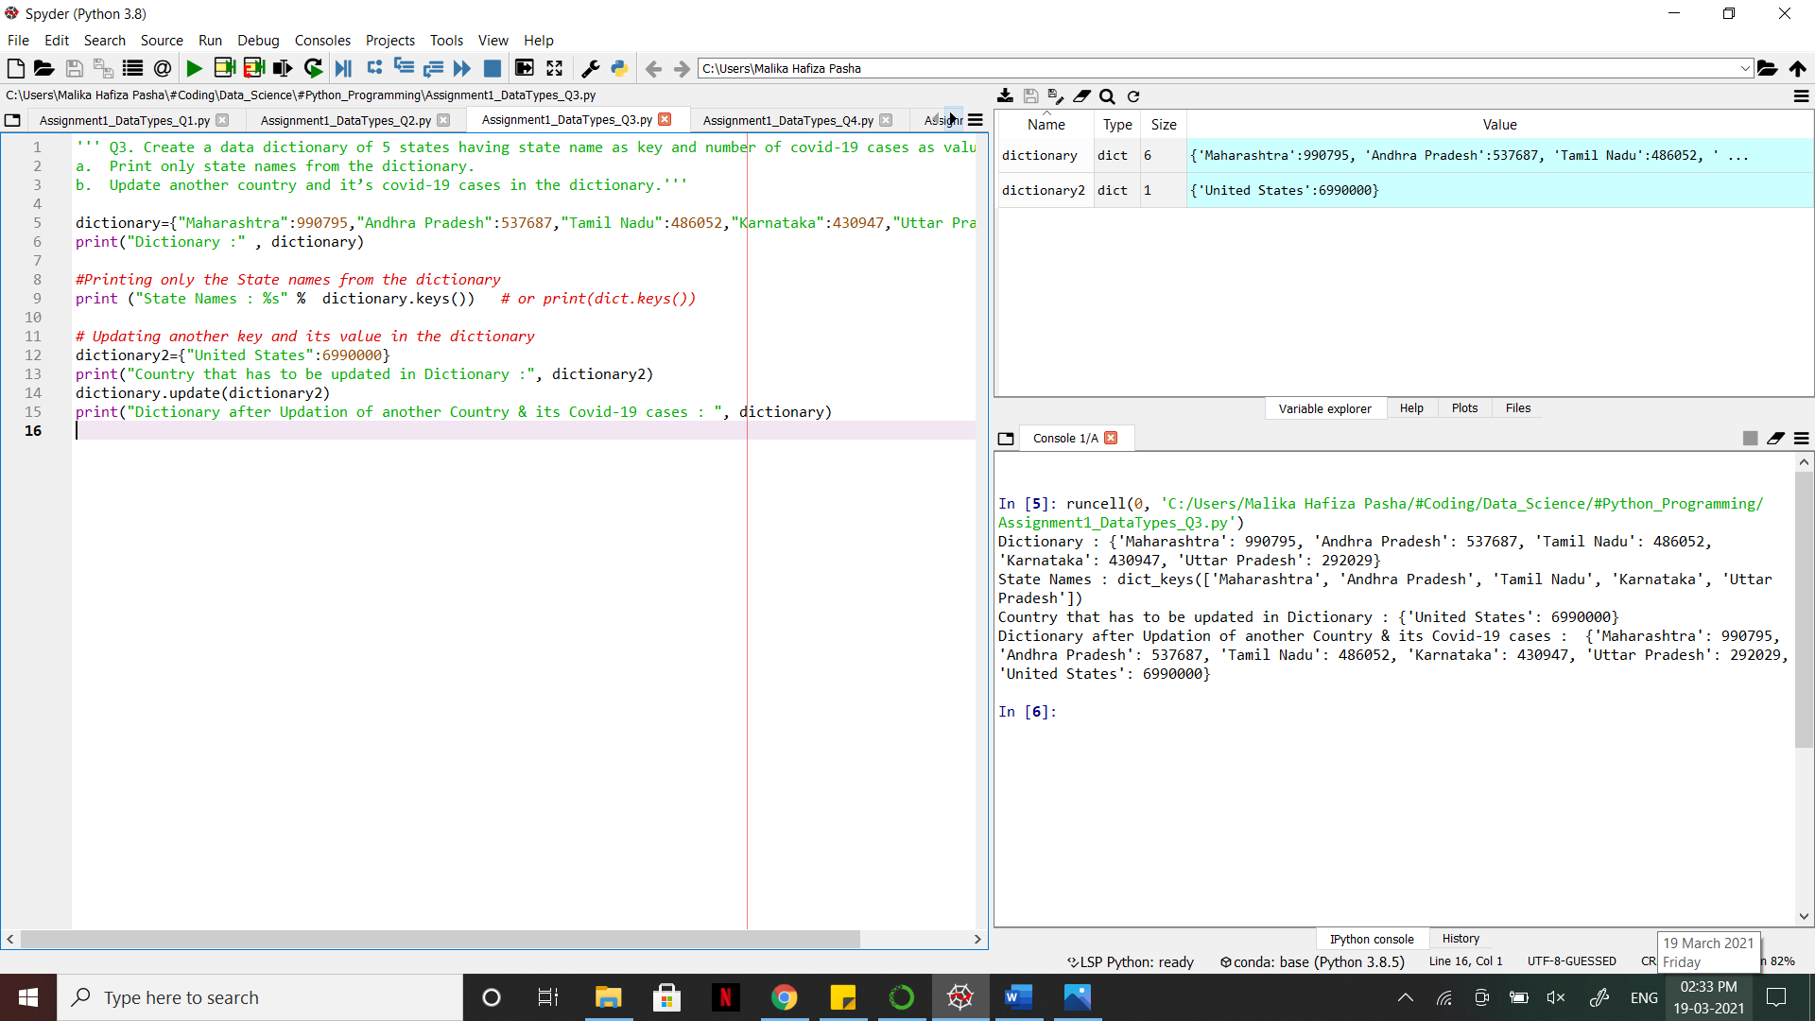

1. Write a Python program which will find all such numbers which are divisible by 7 but are not a multiple of 5, between 2000 and 3200 (both included). The numbers obtained should be printed in a comma-separated sequence on a single line.

**Answer:** [Python file is attached with the assignment file]

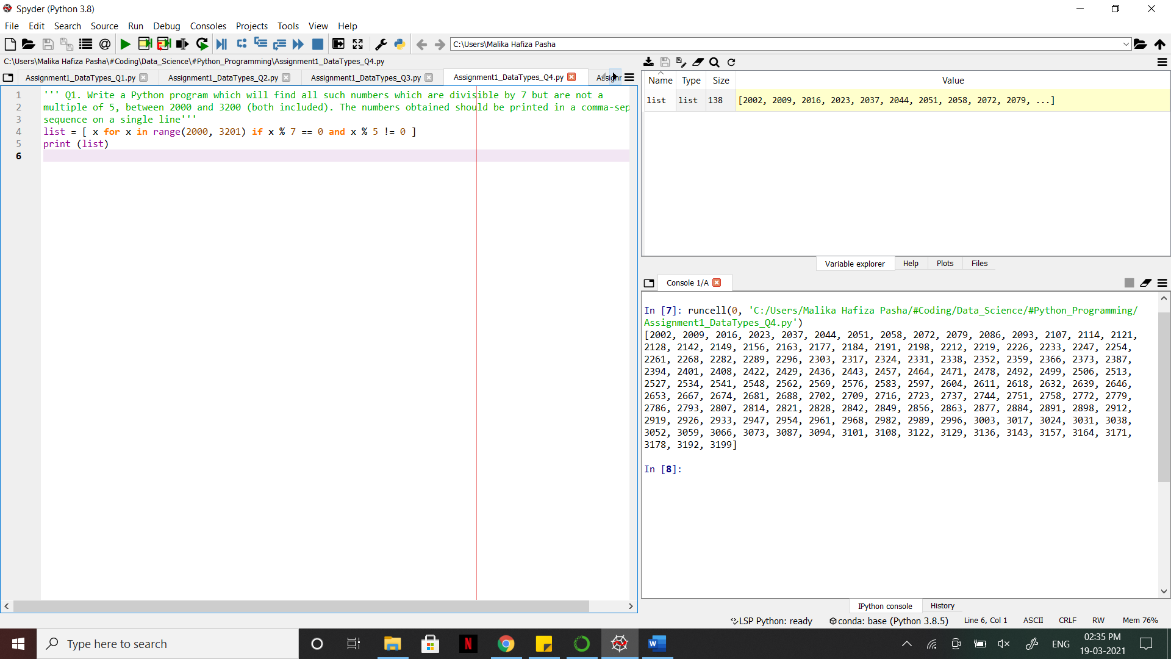

1. Write a program to accept the user’s first and last name and then print it in the reverse order with a space between first name and last name.

**Answer:** [Python file is attached with the assignment file]

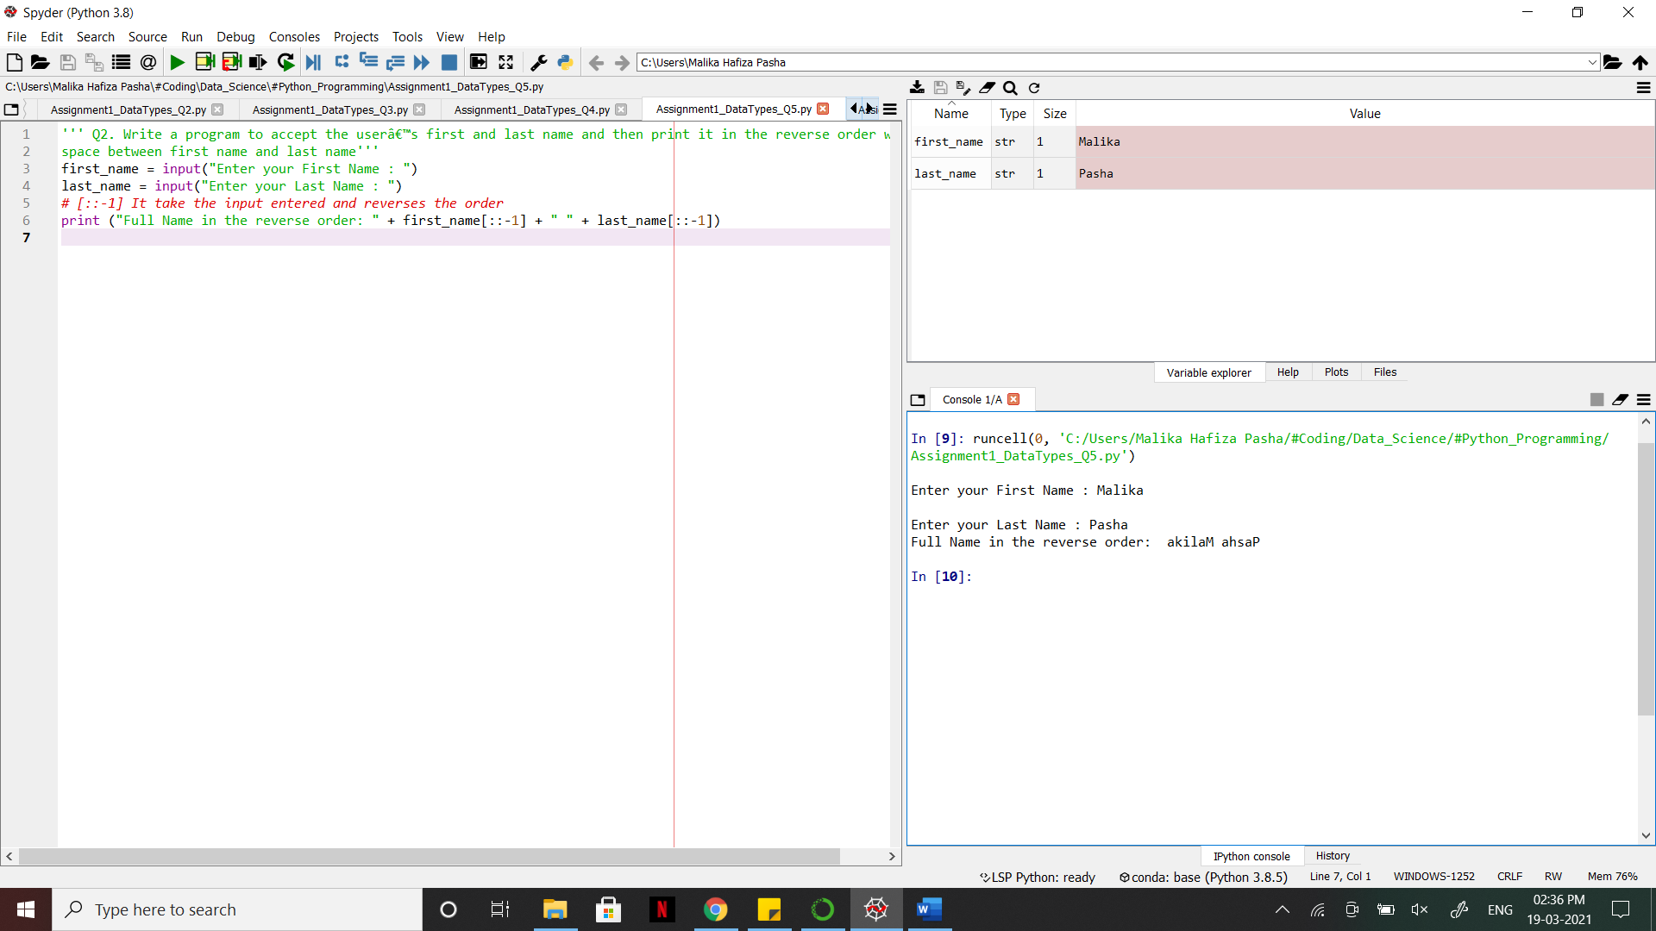

1. Write a python program to find the volume of a sphere with diameter 12 cm.

**Answer:** [Python file is attached with the assignment file]

Formula: V=4/3 * π * r3

